# *Systems III (420-E31-HR)*

# *Lab 1 – Estimation*

Date assigned: Tuesday, August 30, 2017

Date due: Tuesday, August 30 , 2017**, 12:00 p.m.**

**Learning Objectives**

Upon successful completion of this lab exercise, the student will be able to:

* Estimate a project using function point analysis
* Estimate a project using use case points
* Calculate task duration using the PERT formula

To do:

Create a folder named **YourUserName_E31_L01_Estimation** in your 420-E31 folderin your home drive. Download the **E31_L01_Estimation.xlsx** Excel workbook from Moodle into the folder and prefix the name with your username.

**Part A – Function Point Estimation**

1. You have been hired by Heritage College to develop a system to schedule and track co-op interviews. The system should allow the Co-op Coordinator to input information about the companies who have requested interviews, the interview rooms, the interviews that have been scheduled, and the interview results. It should be able to produce reports, such as a company contact list, an interview schedule, and a list of interview rooms, as well as produce thank you letters to be brought into a word processor to customize. You also need the system to answer queries, such as the number of interviews by employer, the number of successful interviews, and the number of no-shows for interviews.
   1. Determine the number of inputs, outputs, interfaces, files, and queries that this system requires. For each element, determine if the complexity is low, medium or high. Record a list for each one in column J and the number in the appropriate cell in the Excel spreadsheet.
   2. Calculate the total processing complexity assuming that there is no effect on the system complexity due to: data communications, heavy use configuration, end-user efficiency, installation ease, or multiple sites. There is minimal complexity due to: transaction rates, performance and distributed functions. There is a moderate complexity on complex processing, extensibility, and reusability. There is a great effect on providing the information online for entry and update and operational ease.
   3. Assuming you choose to develop the system using VB, enter the calculation for the project time required in the empty cells in column C of the spreadsheet. Use the formulae in column B to determine what the calculation should be.
   4. Assuming you choose to develop the system using ASP, enter the calculation for the project time required in the empty cells in column D of the spreadsheet. Use the formulae in column B to determine what the calculation should be.
   5. Assuming you choose to develop the system using C#, enter the calculation for the project time required in the empty cells in column E of the spreadsheet. Use the formulae in column B to determine what the calculation should be.
   6. Assuming you choose to develop the system using Java, enter the calculation for the project time required in the empty cells in column F of the spreadsheet. Use the formulae in column B to determine what the calculation should be.
   7. In cell A61, explain the disadvantages of using this technique as an estimation technique for you developing the system.

**Part B – Use Case Point Estimation**

1. A Real Estate Inc. (AREI) sells houses. People who want to sell their houses sign a contract with AREI and provide information on their house. This information is kept in a database by AREI and a subset of this information is sent to the citywide multiple listing service (MLS) used by all real estate agents. AREI works with two types of potential buyers. Some buyers have an interest in one specific house. In this case, AREI prints information from its database, which the real estate agent uses to help show the house to the buyer (a process beyond the scope of the system to be modeled). Other buyers seek AREI’s advice in finding a house that meets their needs. In this case, the buyer completes a buyer information form that is entered into a buyer data base, and AREI real estate agents use its information to search AREI’s data base and the multiple listing service for houses that meet their needs. The results of these searches are printed and used to help the real estate agent show houses to the buyer.  
     
   Major use cases are listed by actor:  
     
   **Seller**
   1. Sign contract – a simple use case where the seller signs the contract.
   2. Give info about house – a simple use case where the seller tells the information about the house he is selling.
   3. Submit information to MLS – a 5 transaction use case that ends up sending the information to a separate and well-defined system with a well-defined API.

**Realtor Staff**

* 1. Add information to database – a use case with 9 transactions to add information to the database
  2. Print specific house information (for showing to buyer) – 2 transactions one to search and other to print.
  3. Service general buyer process -- note this sequence is very complex.

**Buyer**

* 1. Complete Buyer Information Form – a simple couple of transactions to tell the realtor what the buyer wants.

The use case diagram for the system follows:

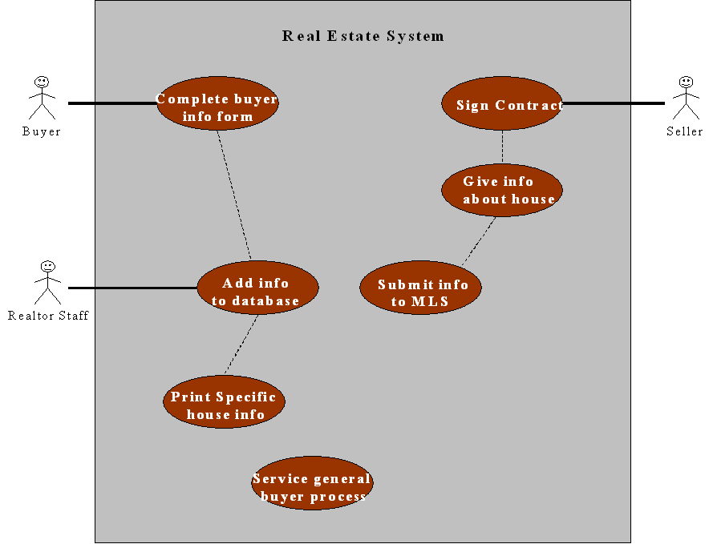****

MLS System

It is critical that the system be easy to use and very efficient for the online user. It is also important that the system be easy to change and have direct access for the MLS system. Nothing else is technically complex; however, senior management in the company insists that code re-use be a consideration, albeit very minor, and that the auditors’ security information be given some very minor priority as well.

The system is being developed entirely by part-time staff that has never used the programming language that was decided upon. The Lead Analyst is strong with some limited object oriented experience, but a great deal of application experience. A brand new system development process is being implemented with no training provided. The staff is very motivated to get the system completed and have a determined a set of requirements which are very stable, although a few minor changes are expected.

Using the techniques discussed in class and the second worksheet in the Excel workbook, complete the use case point worksheet to estimate the effort to build the application.

**Part C – PERT Analysis**

1. Copy the following table into a new sheet into the Excel workbook. Name the sheet PERT. Using the PERT formula presented in the notes, create a formula in Excel to calculate the most likely duration for each of the tasks:

|  |  |  |  |  |
| --- | --- | --- | --- | --- |
| Task | Optimistic  Duration | Pessimistic  Duration | Expected  Duration | Most Likely  Duration |
| A | 3 | 6 | 4 |  |
| B | 1 | 3 | 2 |  |
| C | 4 | 7 | 6 |  |
| D | 2 | 5 | 3 |  |
| E | 3 | 9 | 6 |  |
| F | 3 | 13 | 4 |  |
| G | 4 | 11 | 7 |  |
| H | 12 | 30 | 21 |  |
| I | 8 | 15 | 12 |  |
| J | 3 | 5 | 4 |  |

**To submit**

When you have completed the assignment, create a zip file of the folder, name it **YourUserName_E31_L01_Estimation**, and upload it to the Moodle page for this course.